Job Description – Laboratory Assistant (Apprentice)
Company Name: | Cormica Bradford Limited
Employee Name: | Insert
Date Of Description: | Insert
Role Title: | Laboratory Assistant (Apprentice)
Reports To: | Insert
Direct Reports: | Joanna Kucharska
Responsibility For: | Supporting Facilities and Operations teams.
Location: | Bradford

Role Purpose
The role holder is part of a team who are responsible for ensuring Cormica Bradford has an appropriate Quality Assured working environment for its employees and activities. The role focusses on supporting the Facilities and Operations teams with the day-to-day running of the laboratories, particularly with regard to calibrations, performance verifications, chemical and samples stores support, and laboratory administration. The holder reports to the Facilities Officer.
In agreement with their line manager, the Laboratory Assistant will schedule their daily work activities in the order:
- Supporting the Operations team with laboratory-focussed tasks (calibrations, chemical and sample store support, and similar)
- Working with the Facilities team to complete with daily, monthly, quarterly and annual laboratory housekeeping and administration duties.
- Responding to ad hoc requests for assistance in the laboratories and stores.

Main Duties
Operational
- Proactively responding to day-to-day issues impacting the working environment, particularly in relation to laboratory tidiness.
  - Receive instructions to carry out tasks using agreed procedures and schedule those tasks according to agreed priorities. Be the point of contact for colleagues and senior staff with regard to specific tasks and areas.
- Deputising for the Sample Store Controller; review of items in the quarantine area of the sample store to ensure that there is an identified owner of each item. Daily review of cleanliness and tidiness in the sample store area, rectifying issues.
  - Supporting the day-to-day running of the scientific laboratories site. Carrying out essential tasks, including logging samples into databases, updating clients on receipt of samples, and following up on missing paperwork.
- Ensure the quality of the balances, including weekly calibrations (as per defined rota), but also includes an assessment of the general quality of the balances, door movement, displays clear, equipment clean, ease of access etc. Ensuring balances are correctly supplied with printer paper / ribbons.
- Control and maintain laboratory stock levels by assisting with deliveries and informing relevant staff of the arrival of standards, reagents, solvents etc. Booking in and labelling of standard laboratory reagents and solvents, plus transfer to appropriate locations. Organisation and administration of the chemical stores.
- Ensure that the autopipettes and dispensers are fit for use. This includes ensuring calibration has been carried out according to the rota, but also consideration of the operating mechanism generally, cleanliness, ease of operation of the dial etc.
  - Performing scheduled calibration, performance verification and maintenance of laboratory analytical equipment as required, and where trained to do so, in accordance with documented procedures.
  - Participating in essential facilities site tasks such as safety checks, lab housekeeping, dealing with deliveries, processing waste collections, monitoring of temperature control system etc.
  - Liaising with vendors / contractors to organise service, maintenance, repair of facilities and equipment.
- General housekeeping of the laboratories to meet GMP / GLP standards: ensuring all surfaces are clean; small items of equipment are in the correct place; PPE gloves, tissues and other items are properly stored; solvent wash bottles are topped up and appropriately placed; sink areas are suitable for purpose, clean and ready to use; paper towels available; no unnecessary glassware left out.
- Other laboratory tasks as identified by Line Manager.
- Recording, filing and archiving information in accordance with SOP
  - Proactively manage their own training, identifying training needs and communicating with line manager to address needs.
Additional Duties
Health and Safety
- Follow and abide by all H&S regulations and report any deviations or improvements to the H&S Officer. Have a responsibility for preparing task risk assessments and COSHH assessments as appropriate.
- Carry out work to all health and safety standards and record keeping requirements
Quality
- Demonstrate an ongoing commitment to Quality. Will follow and abide by all relevant GMP, GLP and ISO9001 regulations and report any deviations or improvements to the QA Manager.
- Provide input into quality documentation and quality actions (including SOPs, analytical procedures, validation protocols, reports, out of specification or trend) as required.
- Meet all required quality and record keeping standards. Pro-active management of assigned quality actions.
Responsible For
- Supporting the Facilities and Operations teams as directed by their Line Manager.
The Company reserves the right to vary or amend the duties and responsibilities of the post holder at any time according to the needs of the Company’s business.

Person Specification
Critical Skills Required
- Strong attention to detail.
- Positive interactions with colleagues throughout the business.
- Approachable, supportive, constructive.
Critical Knowledge/Experience Required
- Literate.
- Numerate.
Required Qualifications
- GCSE qualifications in English and Maths.
Beneficial Qualifications
- Science-Based GCSEs.

Human Skills (Skills and special aptitudes)
Approachable | Inclusive
Accountable | Proactive
Communicates Effectively | Resilient
Collaborative | Responsible
Customer Focus | Resourceful
Decisive | Self-Development

Values
- We work together
- We have ownership
- We do what is right
- We are our community
- We continually improve
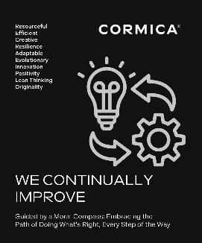
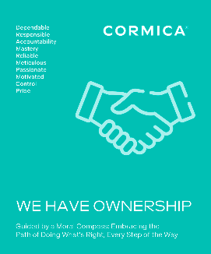

Authorisation

Approved By: [Name]

Position: [Job Title]

Signature: Date:

Incumbent:

Signature: Date:

Supersedes: |  | Effective Date:

